

SpRINT 1 Plan

# Subin Jeong, Joowon Lim, Hakyeong Kim, Tim Burkhart, mitchell etzel

Product Name: Haru (하루)

Team Name: One Day

Sprint Completion Date: 07/11/2016

Revision Number: 3

Revision Date: 07/17/2016

# Sprint Goal:

As a team we want to create a working prototype of our product so that we have a solid starting point for all future tasks and sprints that will need to be completed.

# Task listing

1. As an app manager, I want to connect to the user’s GPS data so that we can track the location of the user throughout their day. (3)
   1. Start Android Studio Project (1 hour)
   2. Link Google Maps API (1 hour)
   3. Generate Correct Permissions to Track Phone’s GPS (2 hours)

Estimated time: 4 hours

1. As a user, I want to see a Google Map so that I can keep track of where I went throughout my day on the map. (5)
   1. Load Google Maps API Activity into Android Project (1 hour)
   2. Build into the Generated User Interface (1 hour)
   3. Link Google Maps Functions to User Interface Actions (3 hours)

Estimated time: 5 hours

1. As an app manager, I want to draw tracks on the map to provide the user with the ability to see a daily path of where they went throughout their day. (13)
   1. Create a Template to save the GPS location and time spent there (4 hours)
   2. Automate how application keeps track of info throughout the day (6 hours)
   3. The track color will gradually change as the time passes by (4 hours)

Estimated time: 14 hours

1. As an app manager, I want good documentation for every part of the SCRUM process so that I have a better understanding of what is going on. (3)
   1. Create Template Documents for Each Part of SCRUM Process (3 hours)
   2. Update Documents Continually as New Information is Available (1 hours)

Estimated time: 4 hours

# TEAM ROLES & TASK ASSIGNMENTS

Subin Jeong(Product owner) : 1.a 1.b

Hakyeong Kim(Designer owner) : 2.a

Joowon Lim(Scrum master) : 1.c 3.a

Tim Burkhart(Producer) : 2.b 2.c 3.b

Mitchell Etzel(Producer) : 3.b 4.a 4.b

# Initial burn-up chart

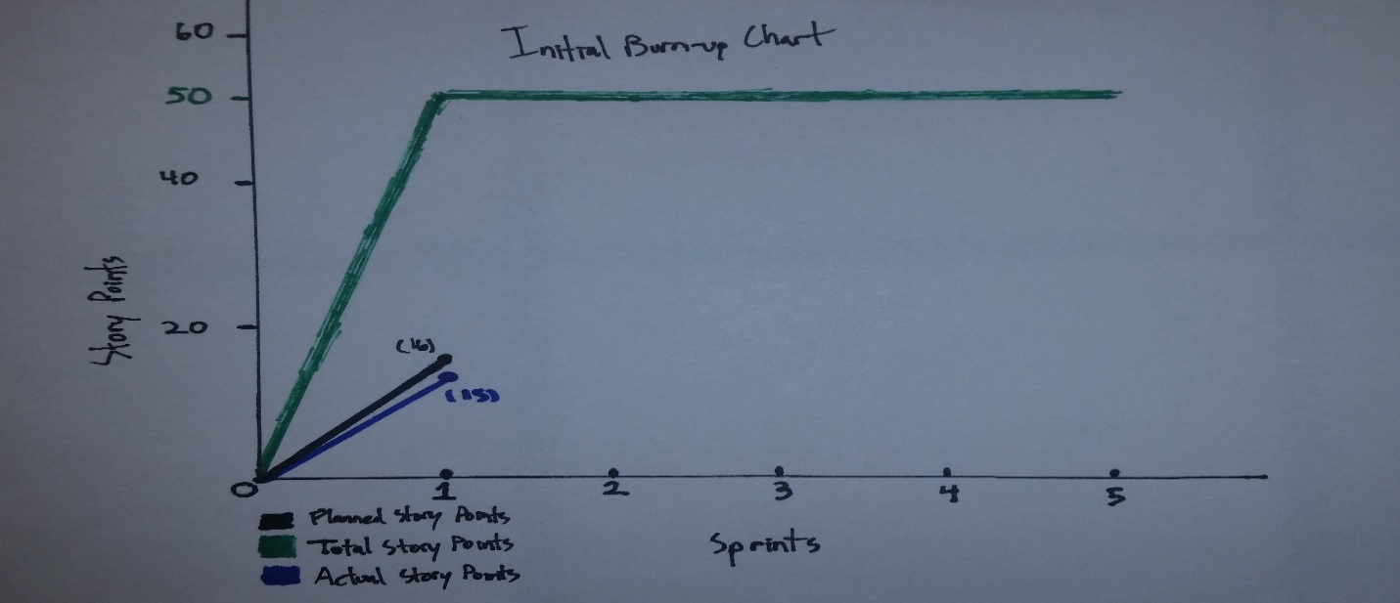

# Initial SCRUM Board

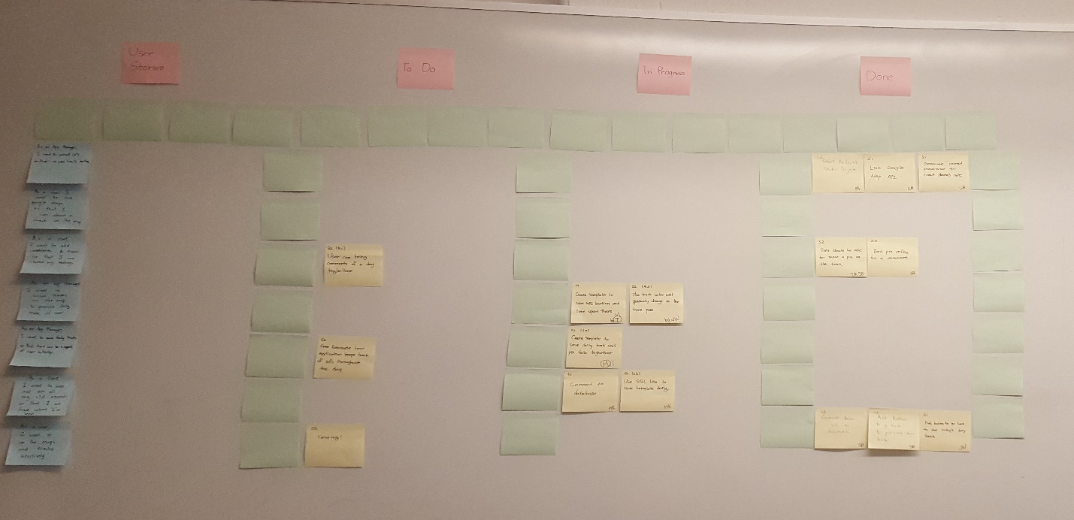

***Final Drafts Available in BSOE 316***